August 24th, 2008
Hi
I was watching on TV (Chinese channel) the end of the Men’s marathon at the Olympic Games a few minutes ago. It was won by a Kenyan. Quite impressive; he just did the last 400 metres around the stadium track faster than most people could do just 400 metres. His overall time was staggering considering the high temperature and humidity. This is the last event at the main stadium. The woman’s Volleyball final is also on now – USA vs. Brazil. Actually, in the last couple of days I got a little more interested in the games, and watched events on the last two evenings. On Friday, this included the last two events in the decathlon – the javelin and the 1500 metres. In the 1500 metres, the US competitor came in last – and got the gold medal!! This is because he had accumulated so many points from the previous 9 events that no-one else could catch him. Also saw the US men and the Jamaican women drop the batons in the relay races; incredible that this can happen at the top level.
Other comments on the games:
- I was disappointed when Liu Xiang, the Chinese 110-metre hurdler had to withdraw at he start of the race due to an Achilles injury. He is one of the few Chinese athletes (perhaps the only one) that was not part of their medal machine and took up the event because be actually wanted to!! That is why almost no-one in China knew him when he won the gold medal in Athens. He has also said publically that he is competing for himself, but apparently ‘changed’ his mind after he was told to shut up and toe the official line!
- Well, Michael Phelps got his 8 gold medals – just in the case of his last individual event. Quite an achievement.
- The last Stanford Alumni magazine featured five of their students at the games; a check on the web showed that four of them got medals.
- Australia was a bit of a disappointment particularly after all the bragging they were doing about how many medals they could get and how they wanted to beat Great Britain – which they didn’t. GB got 19 gold medals (4th position) to Australia’s 14 (6th position). But even GB’s gold haul pales in comparison to the 55 gold medals they got in the 1908 London Olympics (I guess home advantage counts)!
- China with 49 gold medals is on top of the table. But population wise, they are near the bottom. If you take the 6 gold medals won by Jamaica (population ~2.8 million), then China (population ~1.3 billion) would need to get about 2800 gold medals!!
- NZ got 3 golds, 1 silver and 5 bronzes, which is above their average. Their best haul was in LA in 1984 when their tally included 8 golds.
- The equestrian events in HK have finished and everything seems to have gone well. Competitions were held in the mornings and evenings to avoid the heat of the day. Four riders were banned for several years after their horses were found to have been doped.
- The HK team will return with the grand medal total of zero!
- I will watch the closing ceremony this evening and record it, as I did for the opening ceremony. Unlike the opening ceremony, this one has not been rehearsed.

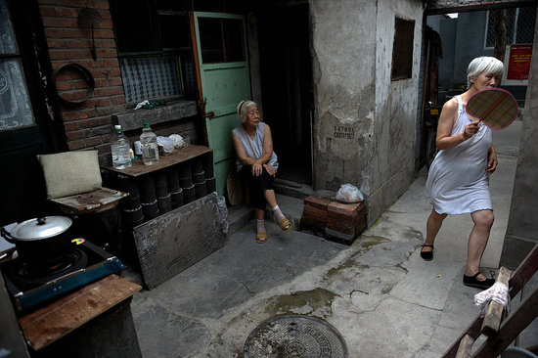
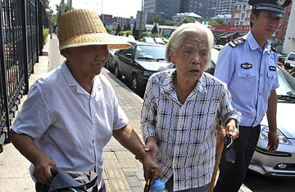
- What did you think of the sham ‘protest’ areas set up in Beijing during the games period? No protests have been approved!! Two elderly ladies (pictures), each nearly 80 years old, wanted to protest as their homes had been demolished to make way for games-related buildings and they received little compensation and are now living in poor conditions (they have made similar protests before). Not only was their petition to protest rejected, they were charged with “disturbing the public order” and have been sentenced to 1 year of ‘re-education’ through hard labour, but not before they managed to get their story out on foreign TV!!!

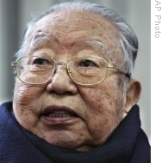
On Thursday, Hua Guofeng, who became chairman of the Communist party on Mao's death, died, aged 87. So, as Mao died in 1976, Hua was quite young when he took over.
On Friday, the T8 storm signal was raised in the morning followed by the T9 later in the day (the first T9 for 5 years). The typhoon was a direct hit though it was not particularly strong so the T10 signal did not have to be raised. The passing of the ‘eye’ over HK cost a swimmer his life at Big Wave bay. As the eye passes, there is very little wind so the water at the beach also became much calmer. So the guy went for a swim only to be caught by the full force of the storm when the other side of the eye arrived, sweeping him out to sea.
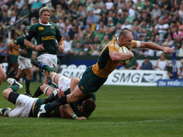
Yesterday, Australia beat SA 27-15 in Durban. Australia could win the tri-nations tournament this year. They play SA again next week and then play NZ in the final game. SA is out of contention with just one win. The team was actually booed off the field yesterday by their own fans.

That’s about it for this week.
Cheers

